**Practical no-1**

**Design a distributed application using RPC for remote computation where client submits an integer value to the server and server calculates factorial and returns the result to the client program.**

**1st file:Factserver.py**

from xmlrpc.server import SimpleXMLRPCServer

from xmlrpc.server import SimpleXMLRPCRequestHandler

class FactorialServer:

def calculate_factorial(self, n):

if n < 0:

raise ValueError("Input must be a non-negative integer.")

result = 1

for i in range(1, n + 1):

result *= i

return result

**# Restrict to a particular path.**

class RequestHandler(SimpleXMLRPCRequestHandler):

rpc_paths = ('/RPC2',)

**# Create server**

with SimpleXMLRPCServer(('localhost', 8000),

requestHandler=RequestHandler) as server:

server.register_introspection_functions()

**# Register the FactorialServer class**

server.register_instance(FactorialServer())

print("FactorialServer is ready to accept requests.")

**# Run the server's main loop**

server.serve_forever**()**

**2nd file: Factclient.py**

import xmlrpc.client

**# Create an XML-RPC client**

with xmlrpc.client.ServerProxy("http://localhost:8000/RPC2") as proxy:

try:

**# Replace 5 with the desired integer value**

input_value = 5

result = proxy.calculate_factorial(input_value)

print(f"Factorial of {input_value} is: {result}")

except Exception as e:

print(f"Error: {e}")

**Execution Steps**

**1. Open Command Prompt:**

On Windows: Press Win + R, type cmd, and press Enter.

On Linux/macOS: Open a terminal.

**2. Navigate to the Script's Directory:**

Use the **cd command** to change to the directory where your Python script is located.

For example:

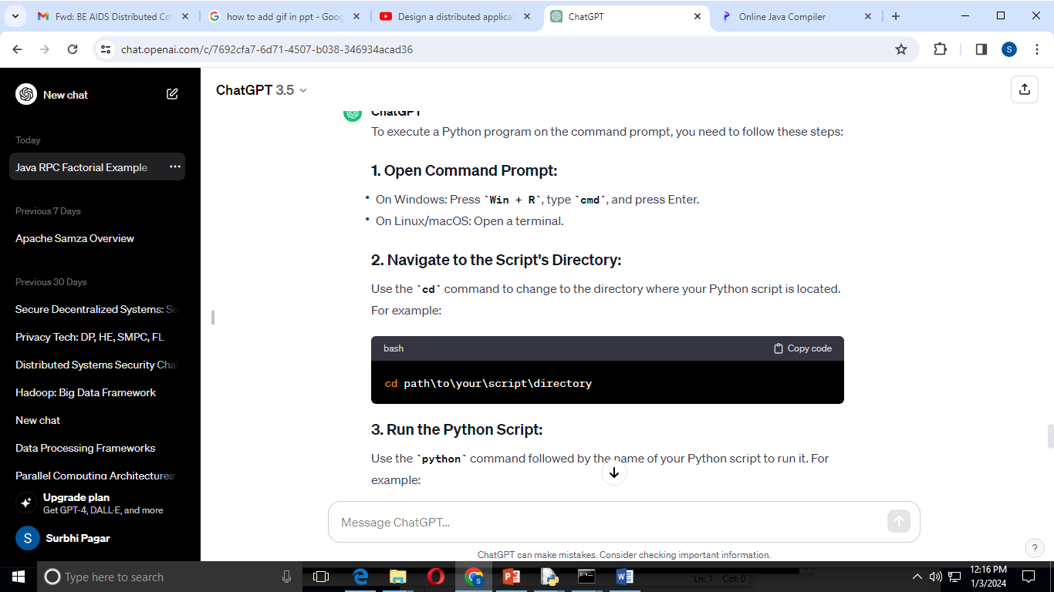

**3. Run the Python Script:**

Use the python command followed by the name of your Python script to run it.

For example:

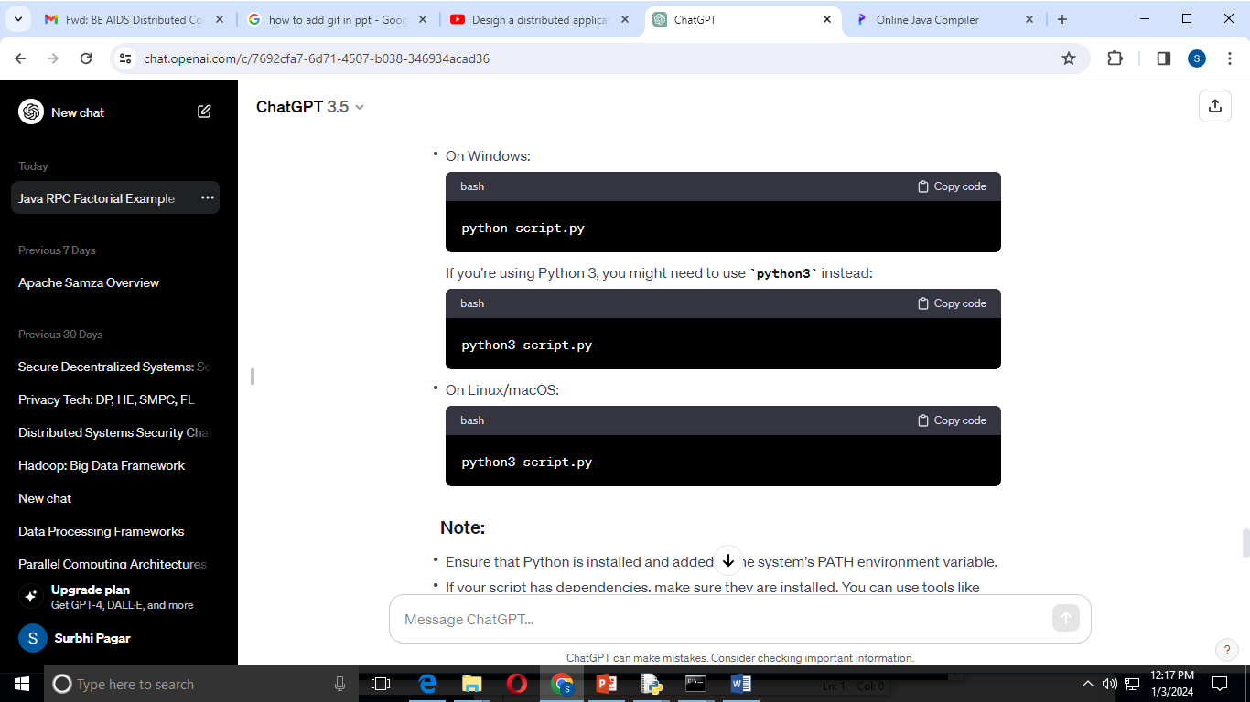

**First execute factserver.py on command prompt**

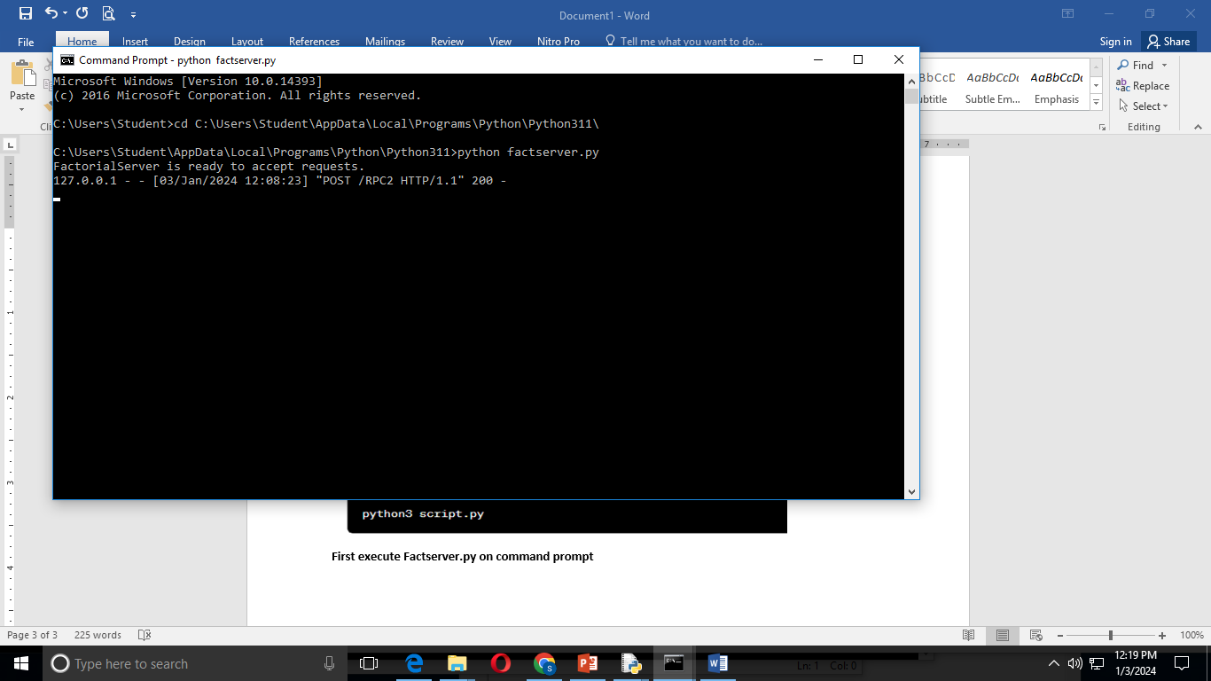

**Then open another Command Prompt window and execute factclient.py**

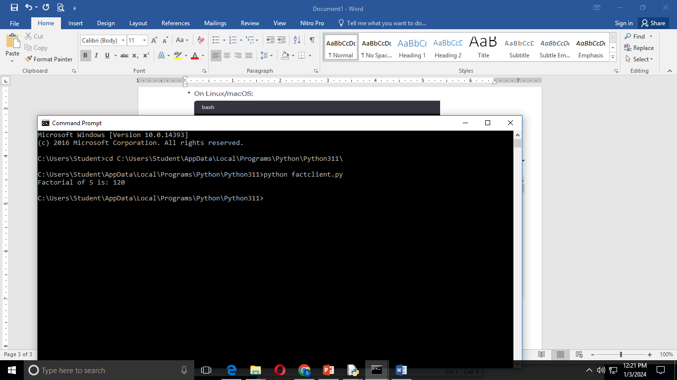

**Reference Link:** [**https://www.geeksforgeeks.org/remote-procedure-call-rpc-in-operating-system/**](https://www.geeksforgeeks.org/remote-procedure-call-rpc-in-operating-system/)